Andre Hardy – Project 11-3

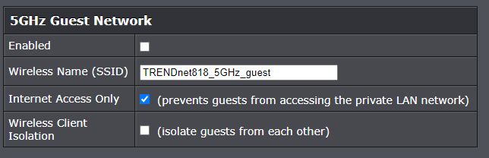

6. Under Broadcast Network Name (SSId), click the down arrow next to enabled. What other option is available? Would it be an advantage to change this setting? Why or why not?
A: To disable it would be an advantage for cloaking

7. Under Frequency (Channel), note that the default is Auto. What does this mean?
A: The frequency channel is chosen by default

9. Under Channel Bandwidth, click the down arrow on 20 MHz. What is the other option? Why would you choose this option? What are the advantages and disadvantages of changing the channel bandwidth?
A: You can change the channel to free up transmission issues

10. Under Security Policy is a single configuration option, Security Mode. Note the default setting. Is this a good option default option? What does wPA2-PSk mean?
A: Wi-Fi Protected Access Pre-Shared Key

